# Identify Suitable Colour Schemes for TopShooter

When making any website or application developers must decide on an effective colour scheme that will not only suit the product being provided but must be appropriate to the applications potential users as well as allow for those with visual impairments to enjoy the product. Choosing the incorrect colour schemes can lead to the readability and accessibility of the developed product becoming unreadable or unusable to some users and in some cases even the development team. If visuals shown use product pictures or even headlines with important messages for users. When developing the pages, the developer should stick to desaturated background colours so that the images or headlines will stand out against it. Using a saturated background will make the content of the page hard to read but any images will lose their effectiveness against the saturated background colour, this can also make the application difficult to navigate.

The development team of TopShooter have decided upon several possible colour schemes for the game to utilise while taking accessibility into account. The following schemes are still to be decided upon by the team.

## Menu Colour Scheme

The menus will make use of the following colour scheme to keep the menus simple yet appealing to users:

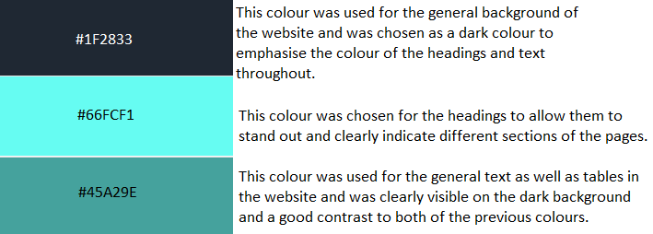

With the use of the colours above the team have designed the following prototype for the main menu/homepage of the game:

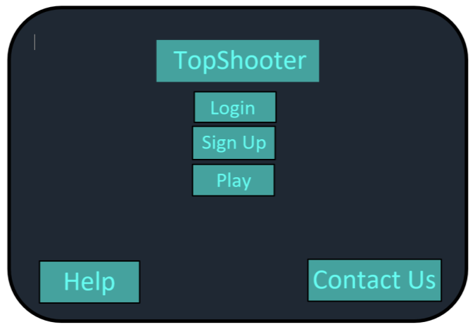

## Game Colour Scheme

### Cyberpunk Neon Theme



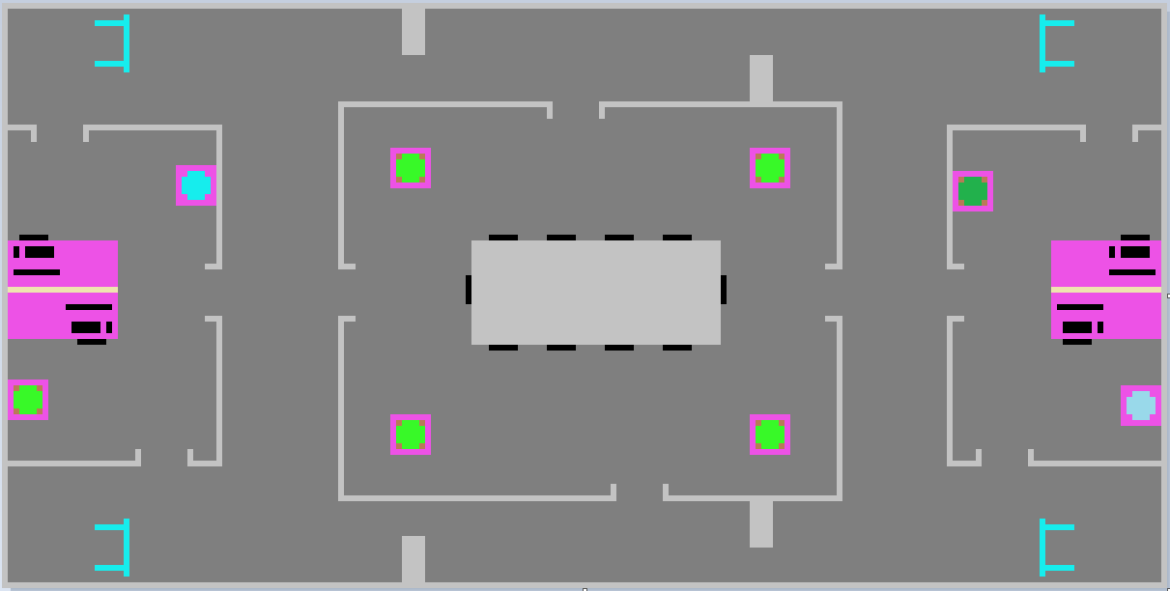

### Fallout Apocalypse Theme



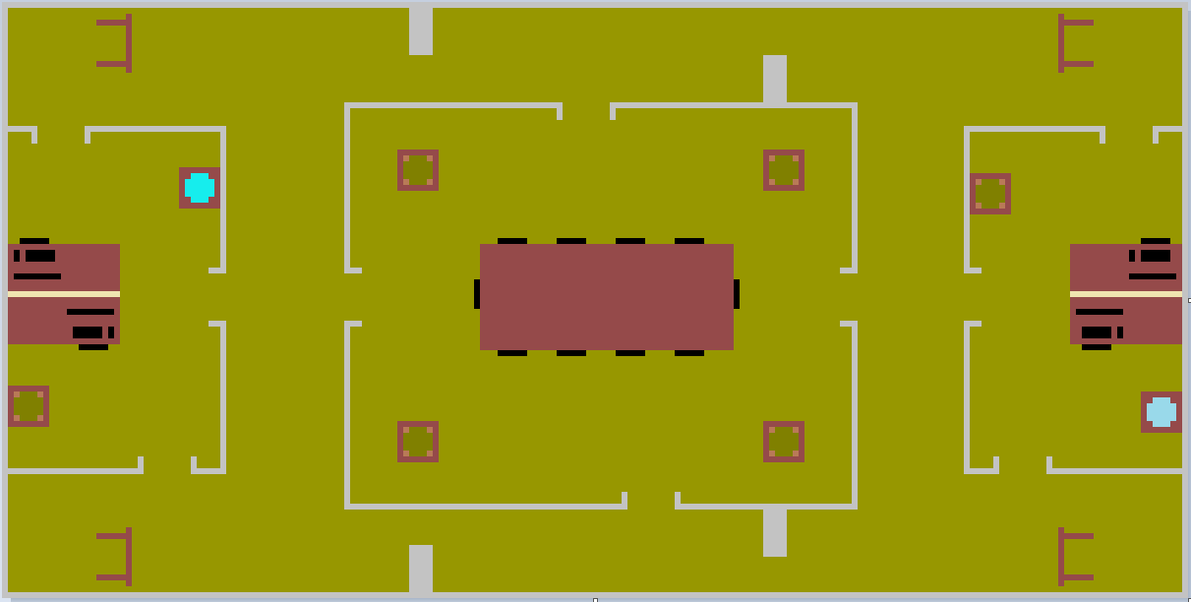

### Noir Bar Theme



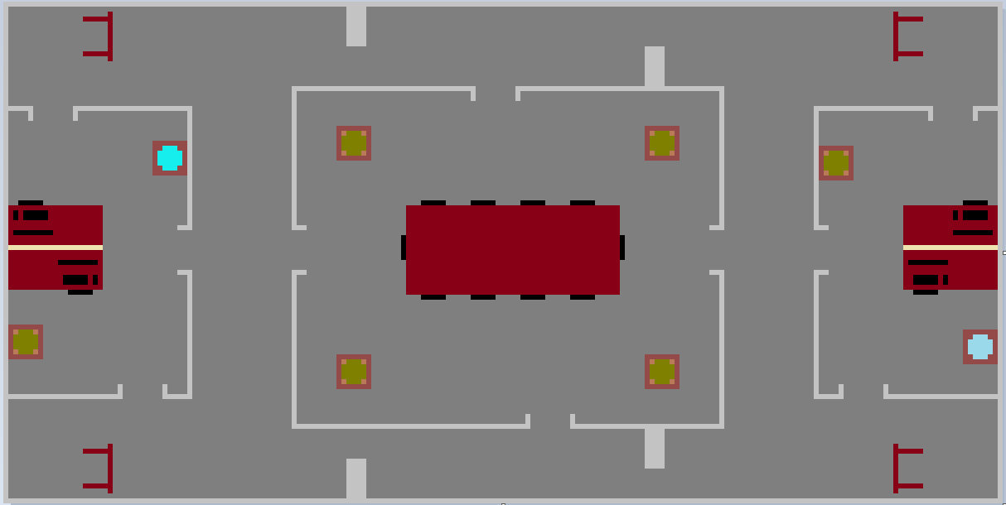

### Hellscape Theme



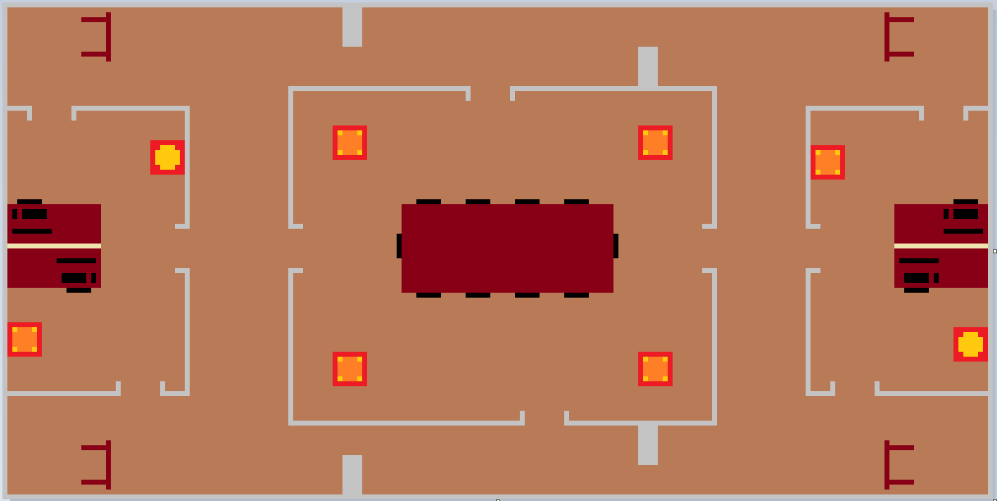

### Tropics Theme



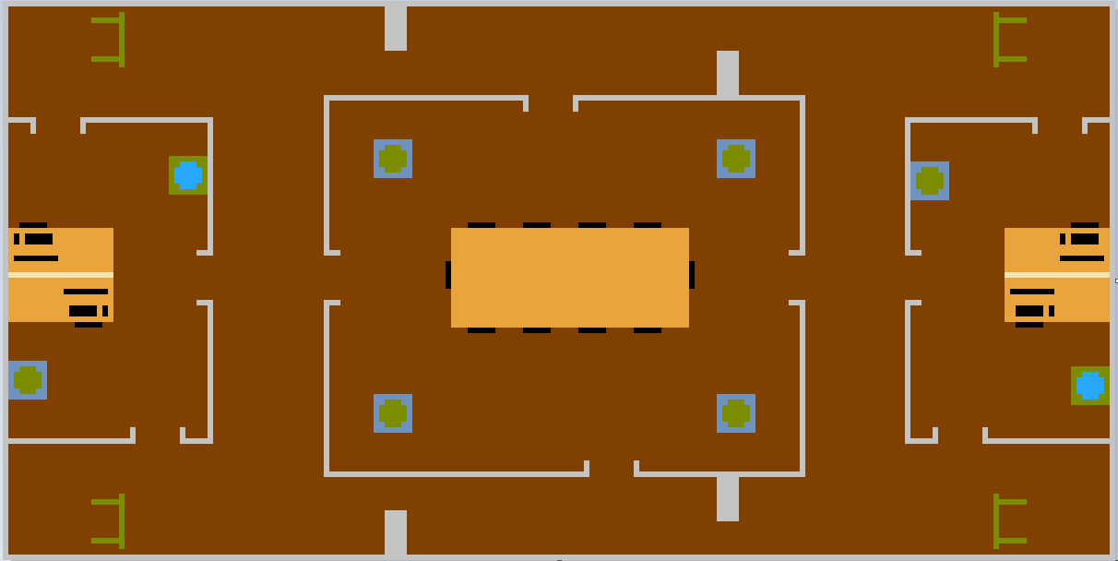

Each of the maps shown for the prototype utilise desaturated base colours to allow for the objects within the map to stand out, the use of continuous grey to indicate walls was also used to contrast well with the desaturated background colour.

Accessibility

With these background colours in mind the team will now need to employ accessibility options for those with visual impairments such as colour blindness. Colour blindness can affect people differently and can be a challenge to add option for every player, but the team have researched various ways of alleviating this problem, the following are examples of ways in which the team can add accessibility for more users.

Simplify Sprites

While taking accessibility into account the team have chosen to simplify the shapes of the characters that players will be able to use so that they can be easily distinguished between the character sprite and the background and objects within the game. Four of these designs can be seen below:



While using these shapes will increase the accessibility and usability of the game overall they will also require to be coloured to better fit the aesthetic that the team has in mind for the game. This leads us to the next point in which some players who have visual impairments such as colour blindness may struggle with being able to see the character sprites due to the colours chosen.

Strict Colours

Keeping to strict colour pallets for the development of the game will be a necessity for creating accessibility. As such the team has opted to keep the backgrounds and objects within the maps at a low saturation while having the character sprites that the players will use at a high saturation, the following colours are examples of the colours chosen to represent the characters:

